Backend Developer Assignment

**Introduction:** Building a RESTful API for a task management system using Node.js, TypeScript, PostgreSQL, Factify and Firebase Functions.

**API Design and Routes:** Design and implement API routes for the following functionalities:

1. **Create a new task**

**URL:** [**http://localhost:3000/tasks**](http://localhost:3000/tasks)

**Request Type:** POST

**BODY:**

{

"title": "walk",

"description": "at 6:00 am daily"

}

**REQUEST:**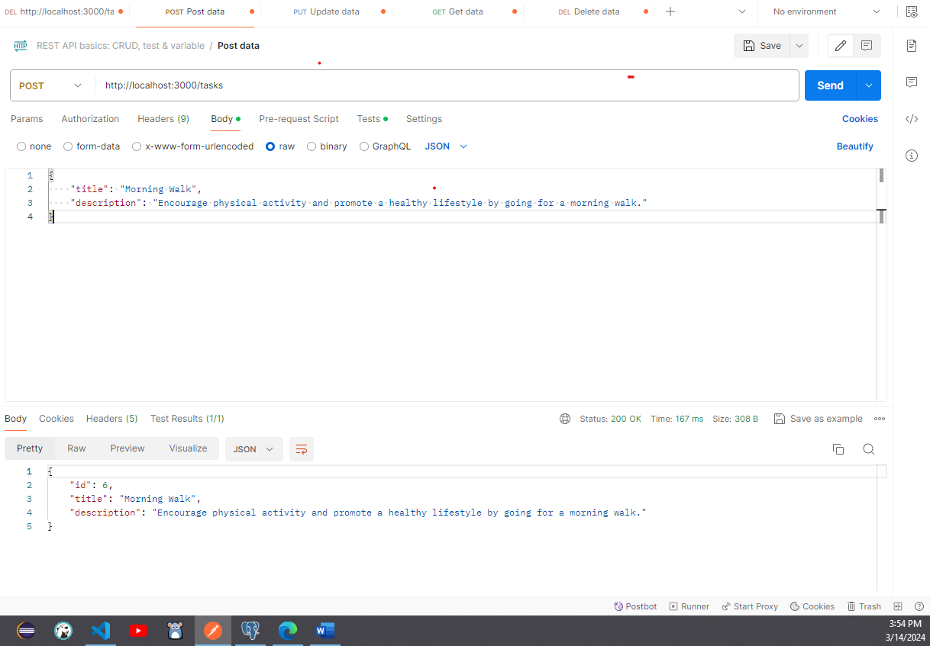

**RESPONSE:**

1. **Retrieve a task by ID**

**URL:** [**http://localhost:3000/tasks/6**](http://localhost:3000/tasks/6)

**Request Type:** GET **REQUEST/RESPONSE:**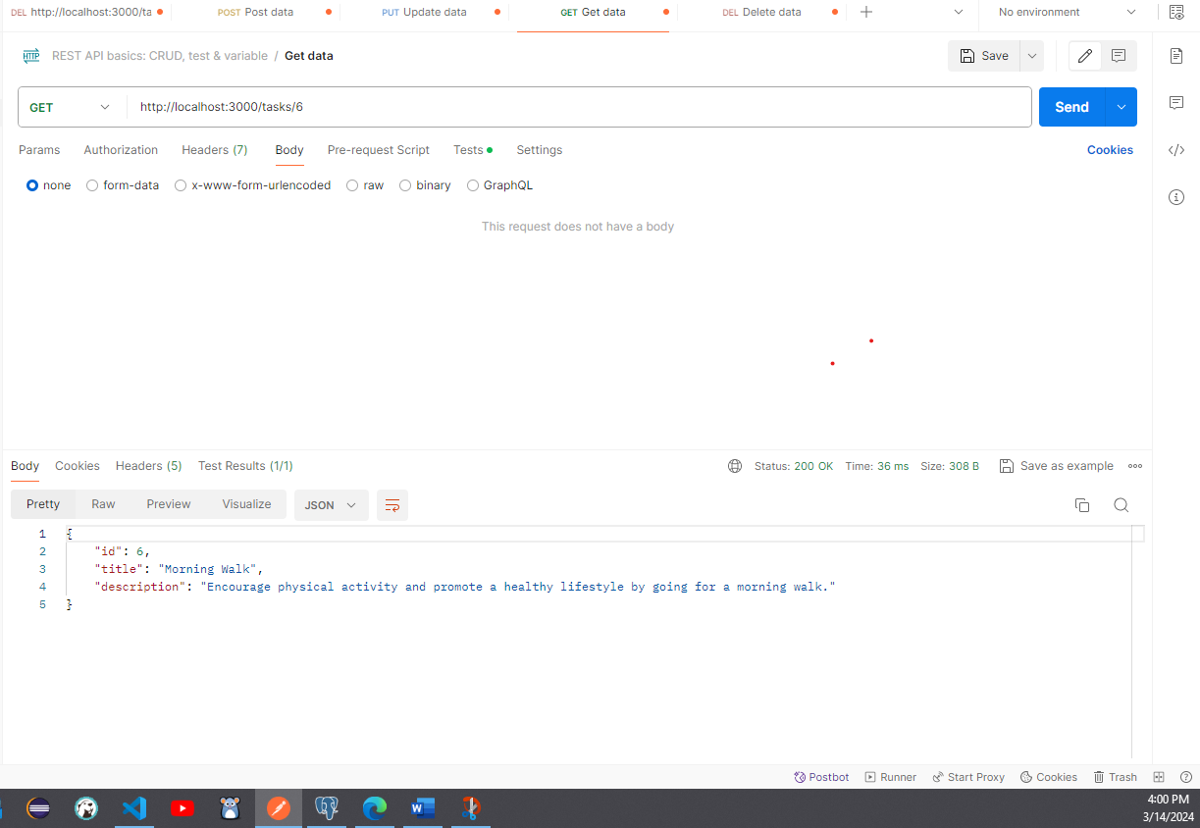

1. **List all tasks**

**URL:** [**http://localhost:3000/tasks**](http://localhost:3000/tasks/6)

**Request Type:** GET **REQUEST/RESPONSE:**

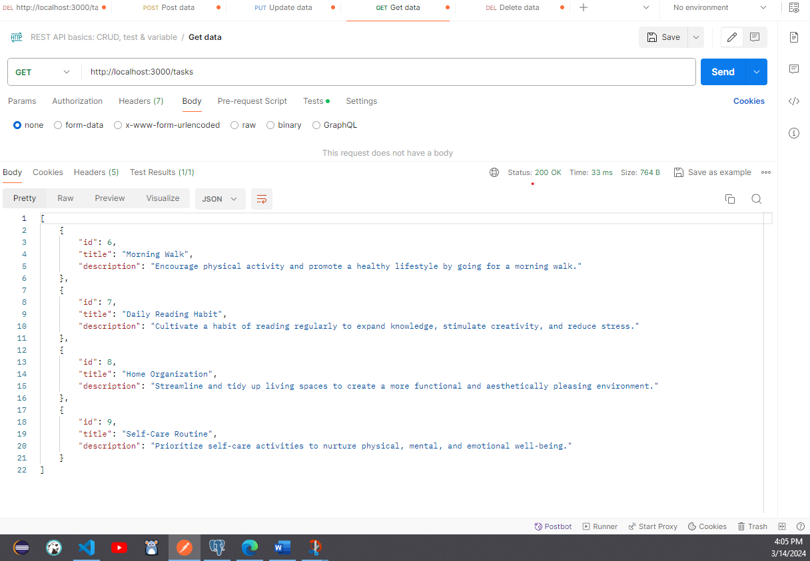

1. **Update a task**

**URL:** **http://localhost:3000/tasks/9**

**Request Type:** PUT

**BEFORE UPDATE:**

**PUT REQUEST:**

**AFTER UPDATE:**

1. **Delete a task**

**URL:** [**http://localhost:3000/tasks/9**](http://localhost:3000/tasks/9)

**Request Type:** PUT

**DATABASE:**

DATBASE: PostgreSQL

BACKEND: Node.js, TypeScript

API TESTING:POSTMAN

**Validation and Error Handling:**

* **npm install fastify-schema-** We import FastifySchema from fastify-schema to define JSON schemas for request validation